# 

# Company Message

We would like to express our gratitude to our clients, experts and partners for choosing our services and acknowledging our value. Our joint aim is to help the energy and mining industry succeed and achieve the strategic vision of Ministry of Petroleum and Mineral Resources to optimize the production, lower the operating costs, increase the asset reliabilities while digitalizing the industry and meeting the environmental and safety goals and targets. We are looking forward to continuing our successful partnership and offering more excellence and value in the future while expanding our services to different geographic markets and regions.

**2**

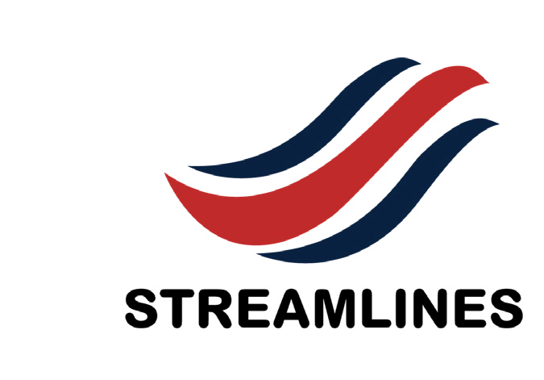**Who We Are**

**Milestones** is a fast-developing energy services company whose aim is to build a port-

folio of oilfield services operating across the entire asset life cycle within the oil and gas industry both onshore and offshore. Milestones has diversified business covers ten blocks: Consultation, software solutions, training, conventional artificial lift and testing equipment, complete sets of thermal recovery equipment, anti-corrosion and anti-abrasion solution, multiphase flowmeter solution, mechanized workover system, EOR (tertiary oil recovery), drilling & completion technology and products plus engineering design.

At Milestones, we aim for excellence in all our services, which cover a broad spectrum of areas and benefit from our global technical expertise. We understand the specific needs and opportunities of E&P companies, so we tailor our solutions to fit your situation. We deliver practical and innovative solutions that add real value to your business. You can rely on our dependable and timely advice that helps you make informed decisions. We are always available to support you with our 24/7 operations support, making sure you get the assistance you need at any time. Technology is constantly evolving, and staying ahead is crucial. With Milestone, you have instant access to our team of experts and cutting-edge technology. Our team has both technical expertise and practical experience to provide the value-added services you deserve from us. We value collaboration and knowledge sharing, working with you as partners to achieve your goals.

**3**

|  |
| --- |
| **Our Products & Services** |

**4**

|  |  |
| --- | --- |
| Artificial Lift | |
|  | Discover the power of Artificial Lift & cutting-edge testing gear in the dynamic world of oil & gas. Unleash the potential of wells with pumps, gas lift & precision monitoring, optimizing production & resource management to new heights! |
| Production Testing | |
|  | We offer a high accuracy clamp on flow meter for water injection monitoring to enable operators to enhance their oil recovery rate. This meter measures the water flows from outside of the pipe and is therefore not in contact with the water itself. There is no risk for corrosion, erosion or scaling from the injection water at all. |
| Software | |
|  | Our software is designed to help you achieve your goals efficiently. Whether you need to interpret seismic data, build static models, simulate reservoir performance, model well and network behavior, allocate production, schedule rigs, manage well integrity, account for carbon emissions, or report drilling activities, our software has you covered. Our software is a comprehensive solution that integrates all these functionalities in a user-friendly interface. |
| Consultation | |
|  | CISS offers a wide array of geoscience and engineering consulting services. Our offerings range from highly focused single-well investigations to fully integrated field studies and field development planning, including project economics and risk assessment. To ensure consistent, high-quality results, CISS applies patented, tightly integrated workflow processes developed while solving complex problems. |
| Training | |
|  | We provide training courses. efficiently designed for industry challenges. Our goal is to deliver a targeted, result- oriented, and collaborative learning experience to boost and develop petroleum professionals. |

|  |
| --- |
| Artificial Lift |

Compound Balancing Pumping Unit Double-horsehead Beam

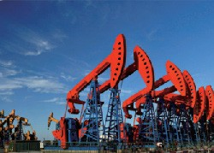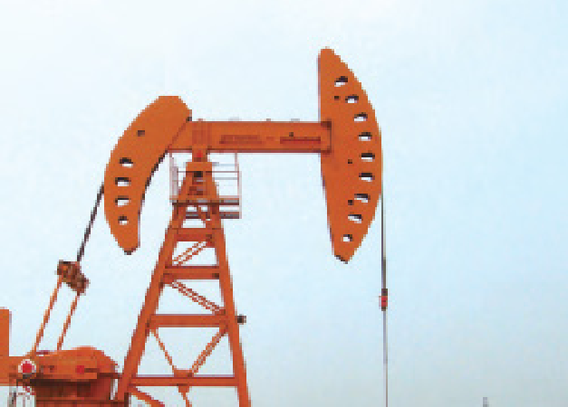

Compound Balancing Pumping Unit creates compound balancing equipment and combines all the advantages of conventional beam pumping unit. At the same time, it reduces electricity usage when the minimum torque is reached.

Double-horsehead pumping unit is based on the model of conventional type. It adopts special curve beam arm. It is one of the ten energy conservation pumping unit that China National Petrochemical Corp recommends, which is able to save more than 20% energy.

Preposition type Double-horsehead Diameter adjust moment regulate

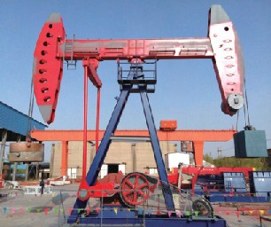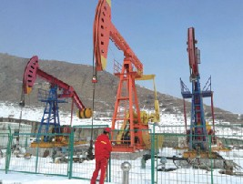

Preposition type double-horsehead beam pumping unit is balanced with mounting horsehead on the back of walking beam, inside counterbalance and hanging balancing weight on the back-horse head. It displays simpler structure, easier ways of rebalancing and maintenance, smaller additional dynamic load, longer stroke length, less energy consumption, greater efficiency and longer service life.

Diameter adjust moment regulate pumping unit has advantages of simpler structure, reliable working quality and convenient repairment. It is extremely suitable for extraction of low and medium viscosity petro and high-water content petro for horizontal well, inclined well and viscous crude well that are hard to extract in normal condition, it is able to extract with greater size of reducer, motor and less SPM.

**5**

|  |
| --- |
| Production Tests |

## 

## Echometer

Introducing our clamp meter – the smart solution for accurate current measurements with- out circuit interruption. Choose from Load Current or Leakage Current models, covering AC/DC and various methods. Discover a new era of effortless and safe measurements. Upgrade now for precision in a single clamp!

Experience unmatched accuracy in depth assessment with Echometer. Using cutting-edge echo-based technology, this compact device de- livers instant, reliable measurements for both water and underground applications. Say good- bye to uncertainty and hello to precise insights, whether you're diving into oceans or exploring subterranean landscapes. Elevate your depth measurement game with Echometer today!

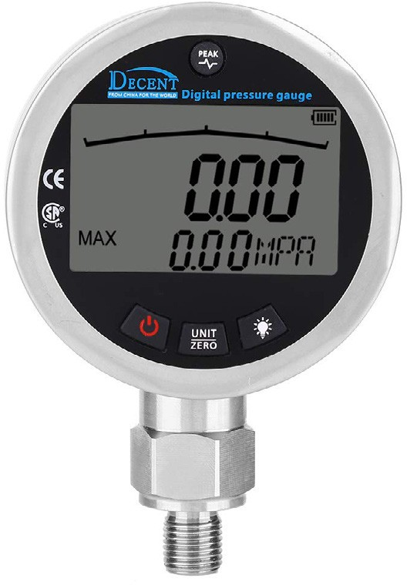

**Digital Pressure Gauge**

Introducing our cutting-edge digital pressure gauges – the future of accurate pressure measurement. Experience the advantage of crystal-clear digital displays that provide instant readings with unmatched clarity. These gauges go beyond tradition, storing and transmitting pressure data electronically for enhanced efficiency. Ideal for industrial, scientific, and medical contexts, our digital pressure gauges excel in measuring gases, liquids, and vapors in various containers.

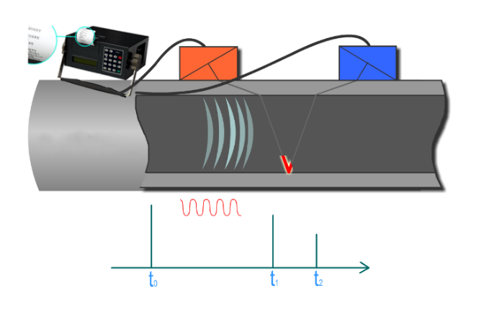

**Ultrasonic Clamp on Meter**

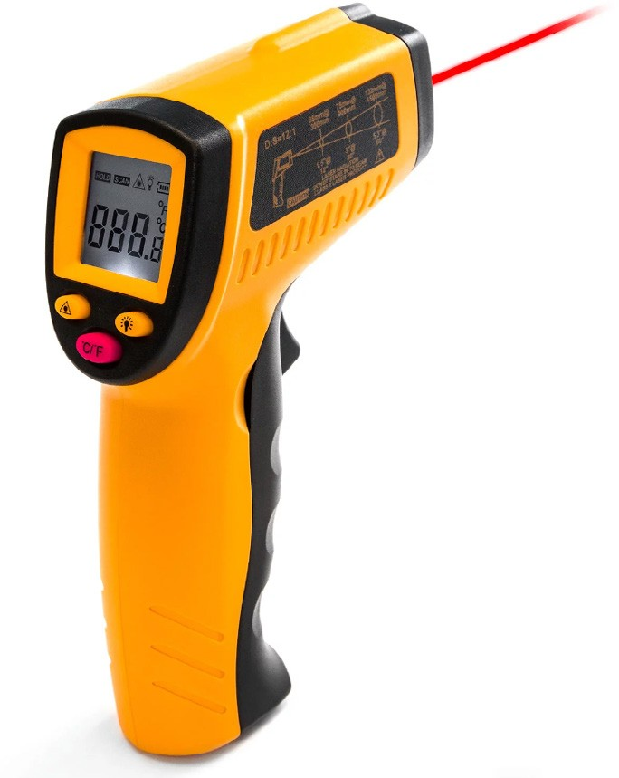

## Heat Guns

Introducing our state-of-the-art IR thermometers – your key to accurate temperature readings from a distance. From machinery to ovens, our devices deliver non-contact measurements with unparalleled ease. Choose your ideal model with adjustable features for diverse applications. Upgrade to precision today!

**6**